WEST LONDON WASTE AUTHORITY
Report of the Head of Service Delivery & Operations Manager | June 2021
Contracts and operations update

SUMMARY
This report provides an update on the Authority’s various waste treatment arrangements and procurements.
RECOMMENDATION(S) The Authority is asked to:
- Note the information within this report.
- Introduction
This report provides an update on WLWA’s existing contracts and operations for managing west London’s waste. This conforms to key strategic outcomes in the new draft joint strategy (JMWMS) ‘Effective and efficient operations focused on where we want to be in the future’, ‘better transport’, ‘carbon neutral by 2030’, and ‘collaborative models in the sub-region and pan-London’.
- West London Residual Waste Services contract
The contract continues to perform well into the new contract year. Performance against the contract targets was excellent in April, with landfill diversion at 100% (target 96.1%) and recycling of residual waste at 4.97% (target 2.1%). Final figures are now available for the last contract year 2020/21, which showed that only 20 tonnes of waste was landfilled, and this was air pollution control residue from the energy from waste process. No contract waste was sent directly to landfill.
WLWA and Suez are progressing a programme of projects for improving the efficiency of the transfer stations. All waste compactors have now been replaced at Transport Avenue which will increase load weights and speeds, and extra weighbridges are currently being installed to increase vehicle turnaround times. This work will be replicated at Victoria Road. Detailed plans have now been developed for replacing the waste crane at Victoria Road and installing new fire suppression systems at both transfer stations.
On 14 May, Suez signed a combination agreement with French utilities company Veolia. It will result in the creation of a ‘new Suez’ owned by a new consortium which will sit under the Veolia umbrella. The end of 2021 is being targeted for sale of Suez to the new consortium. It is not anticipated that this merger will have significant impacts on this contract and Suez is keeping WLWA fully informed as transition plans emerge.
- Viridor residual waste contract (Lakeside)
The contract is generally operating well. Earlier this month a technical issue occurred at Lakeside resulting in an unplanned shutdown, and the flows of materials were successfully managed to other locations whilst repairs were made.
- Food waste contract
Hillingdon moved to separate food collection in the week commencing 4 May and its food is now being bulked at Victoria Road for AD treatment via the Bio Collectors contract.
The new collection is working well and tonnage data will be analysed over the next few months as the arrangements settle in. Ealing and Harrow are also diverting a large proportion of their food waste into Victoria Road (from either Alperton Lane or Transport Avenue) to reduce travel time and increase efficiencies.
- Green waste and mixed organics contracts
These contracts are:
- CountryStyle Recycling Ltd contract – green waste
- West London Composting Ltd contract – green waste and mixed organic waste.
From the end of April WLC ceased treating mixed waste for Hillingdon as it moved to separate collections for both food and green waste. All Hillingdon green waste is now treated separately under the WLC Lot 1 contract. On 4 May Envar Composting (Part of the Heathcote Holdings Group) acquired WLC however operationally all processes remain unchanged.
- Transport contracts
The transport contracts are:
- For transporting non-recyclable waste from HRRCs, provided by J Shorten & Sons Ltd
- For the removal of segregated materials from the HRRC sites in roll-on roll-off containers, provided by Suez transport.
Both contracts continue to deliver a very good service.
- Dry Recyclables
This contract covers the collection of Ealing Council’s dry mixed recyclables from Greenford depot (Ealing) for processing at Viridor’s MRF at Crayford. The contract began in June 2020. Other Boroughs are able to join this contract at a later date. This contract is performing well.
Measures put in place by Ealing to reduce contamination over Jan/Feb 2021 are continuing to work well. The overall number of non-confirming loads and downgraded loads is significantly lower over April and May 2021 compared to the start of the year.
- Website
At the end of April a new contract for the design of WLWA website and intranet was awarded to Makermet. The design and build phase has started and is progressing well.
- HRRCs
WLWA has procured a new booking system which launched near the end of May. The new system operated by Pentagull is quicker and easier to use as residents do not need an account to create or manage bookings. The system is used by sites in Brent, Ealing, Hounslow and Richmond. The booking system helps manage traffic flows, numbers on site to ensure appropriate distancing and provides useful data regarding usage and demand for the services. Going forward as Covid-19 restrictions ease the system will continue to be an essential resource to manage traffic flows and optimise services to residents.
- Abbey Road HRRC and WTS
Abbey Road HRRC and WTS is managed by WLWA on behalf of Brent. The HRRC has been shortlisted for Civic Amenity Site of the Year at the Awards for Excellence in Recycling and Waste Management. It will be up against sites from Buckinghamshire and Newport, with the winner announced at an event on 1 July at the Landmark Hotel in Marylebone.
The successful award submission summarised the improvements made at the site to make it a key part of west London’s circular economy that is leading the way towards Net Zero. The most recent improvements include:
- Development of an on-site workshop for bike refurbishment, which is nearly complete
- Digitisation, meaning that 80% of the site’s paperwork is now electronic
- Extra separation of valuable recyclables including batteries and print cartridges, with further trials in the pipeline for new materials
- Recruitment of two waste minimisation operatives, who will focus on helping residents’ transition to resource efficient behaviours
- Launch of a new visitor survey on garden waste recycling habits to inform service design
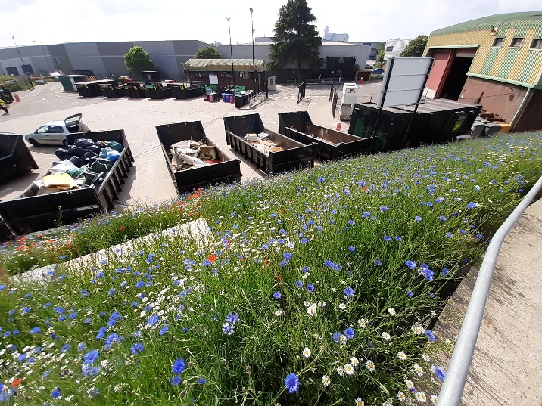
- Wild flower meadows are now in bloom (see photos) and attracting lots of biodiversity
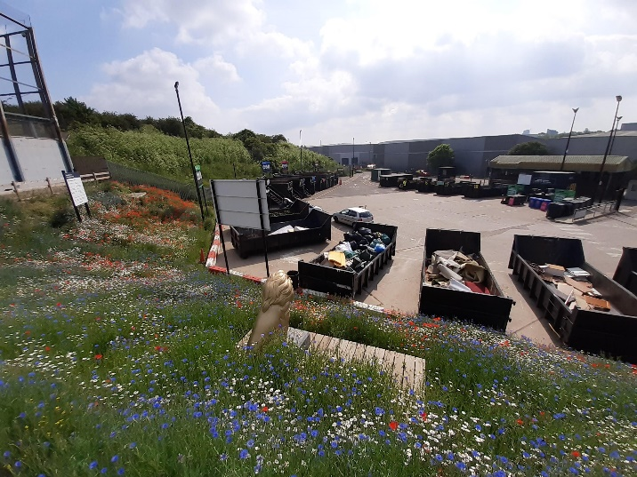
- Health and Safety
A traffic flow assessment is currently being conducted at Abbey Road to address hazard observation reports of traffic related near misses. On-going health and safety work at Abbey Road includes an update of risk assessments and further training and certification.
A new toolbox talk on Covid-19 has been developed and rolled out to all staff.
- Financial Implications
The impacts of the pandemic have led to changes in waste flows, please refer to the budget monitoring report for more information.
- Staffing Implications
None.
- Legal Implications
Any specific legal issues are described in the body of this report.
- Joint Waste Management Strategy Implication - The contracts mentioned in this report meet the Authority’s Joint Waste Management Strategy policies, as described in Section 1.
Contact Officers | Tom Beagan, Head of Service Delivery  tombeagan@westlondonwaste.gov.uk  Sarah Ellis, Operations Manager,  sarahellis@westlondonwaste.gov.uk | 01895 545516  01895 545515

